

Design and Implementation of a CI/CD Pipeline for a Web-Based Application

SUBMITTED BY:
Sarah Nowshid
BSSE
Semester 7th

SUBMITTED TO:
Sir Ijaz Ullah
Subject: Cloud Computing

Project Overview
This project demonstrates a CI/CD pipeline for a simple Student Management System (Flask web app). The goal is to automate building, testing, and deployment to ensure faster delivery, fewer errors, and reproducible workflows.

Tool setup guide:
Tech Stack:
- Python 3.10 + Flask
- Git & GitHub
- GitHub Actions (CI/CD)
- Docker (containerization)
- Azure

Test Results: (screenshots)
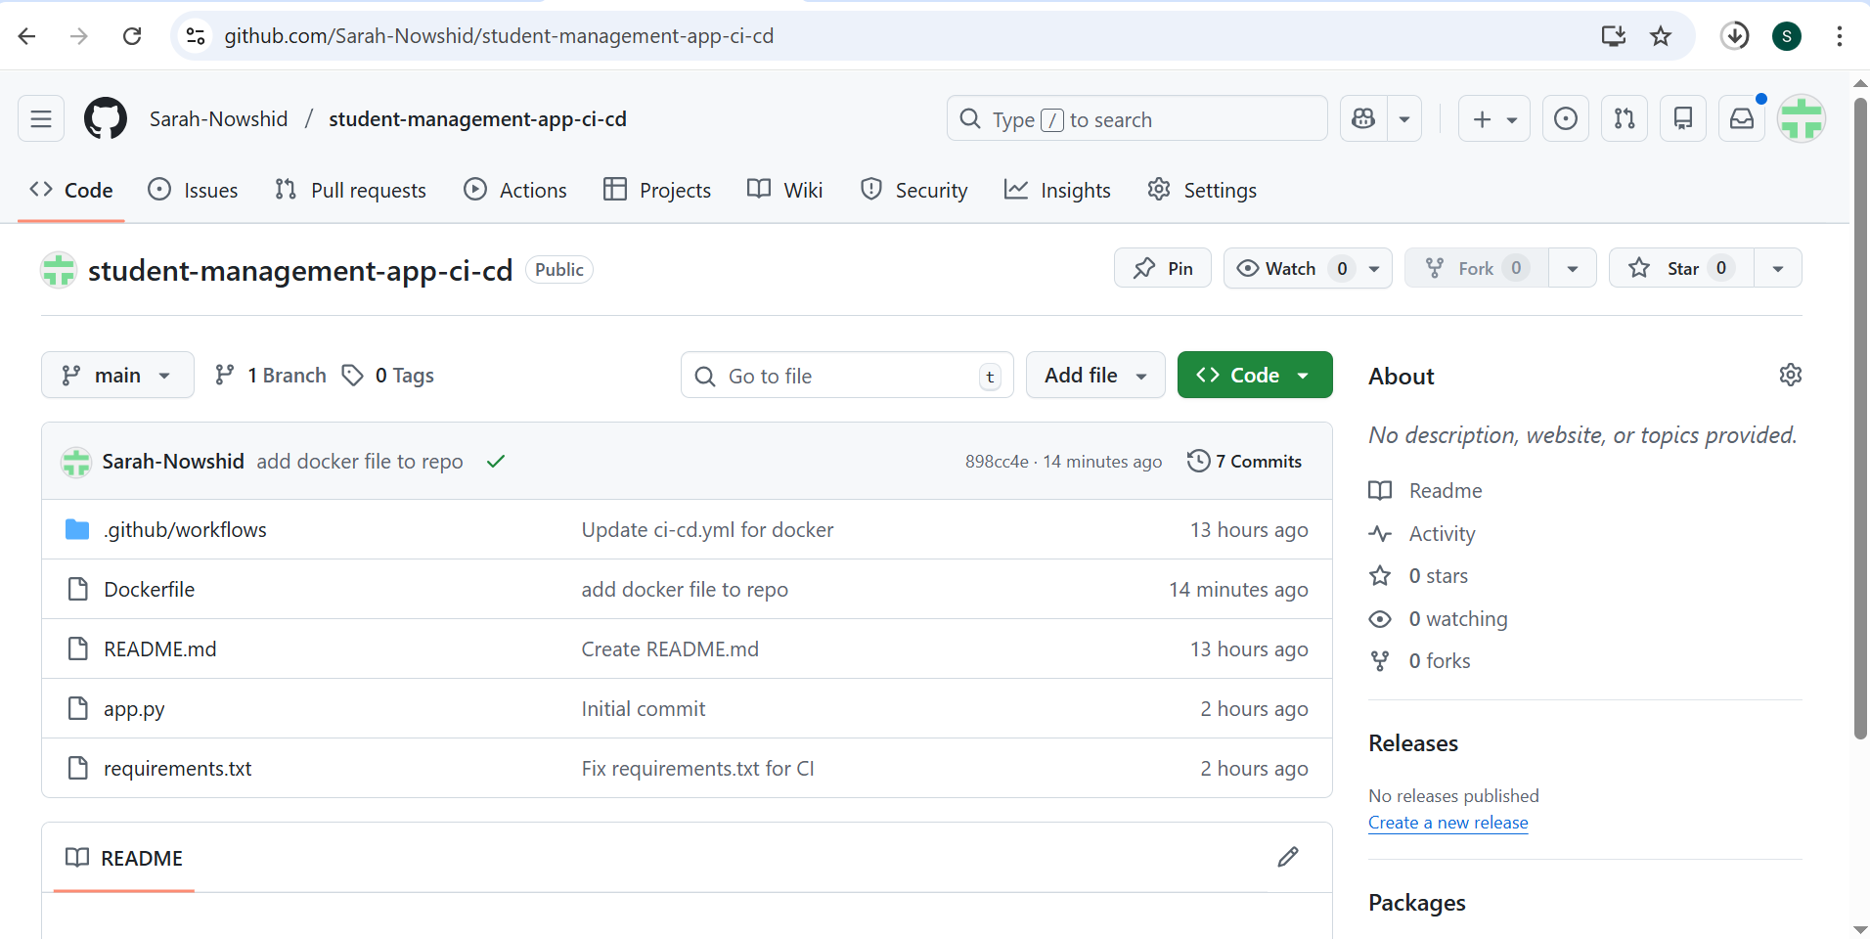

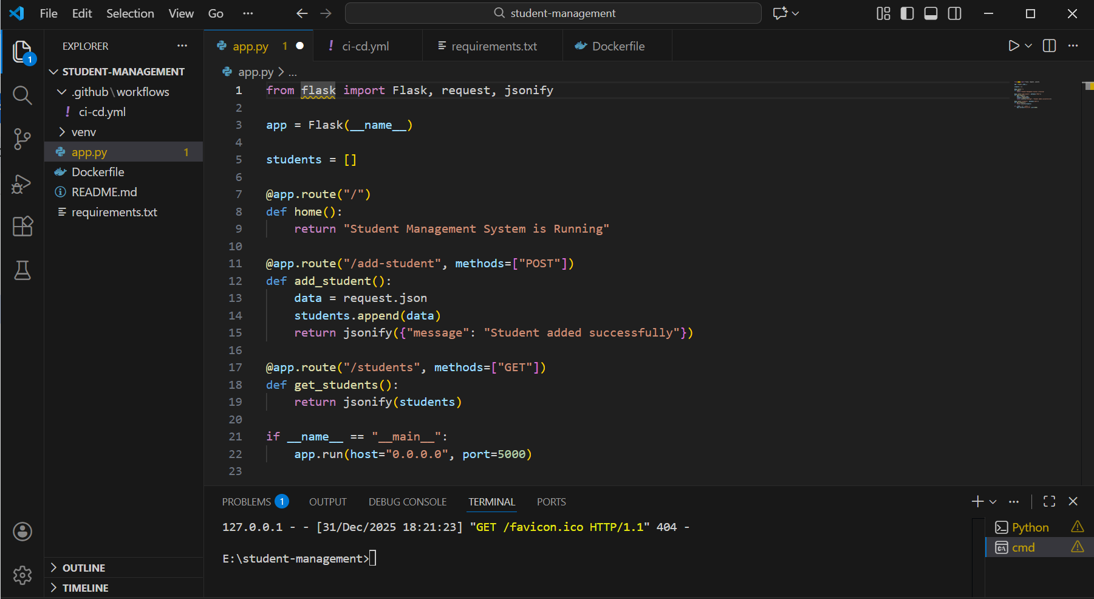
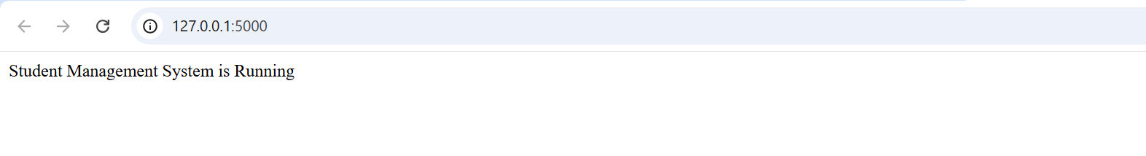

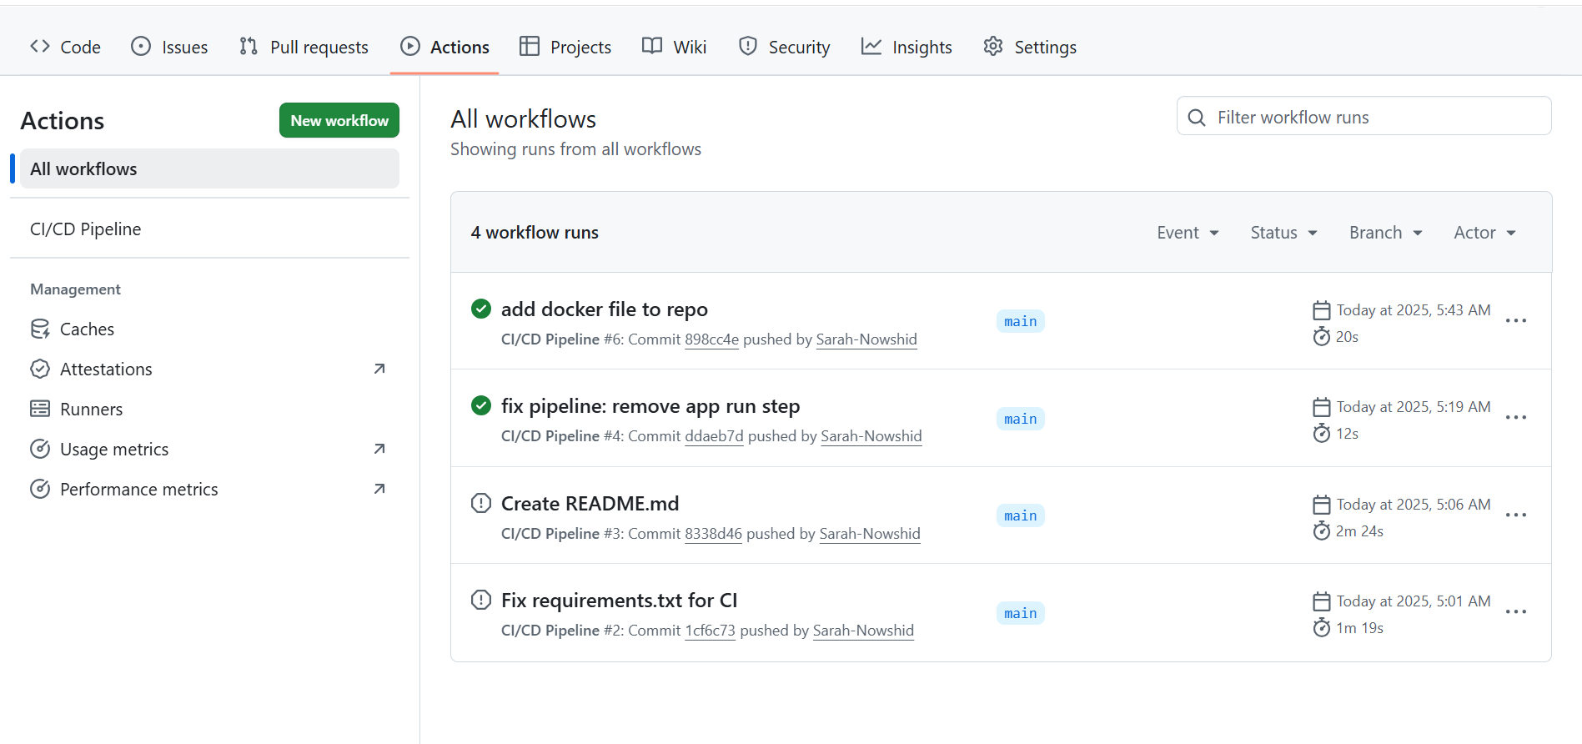
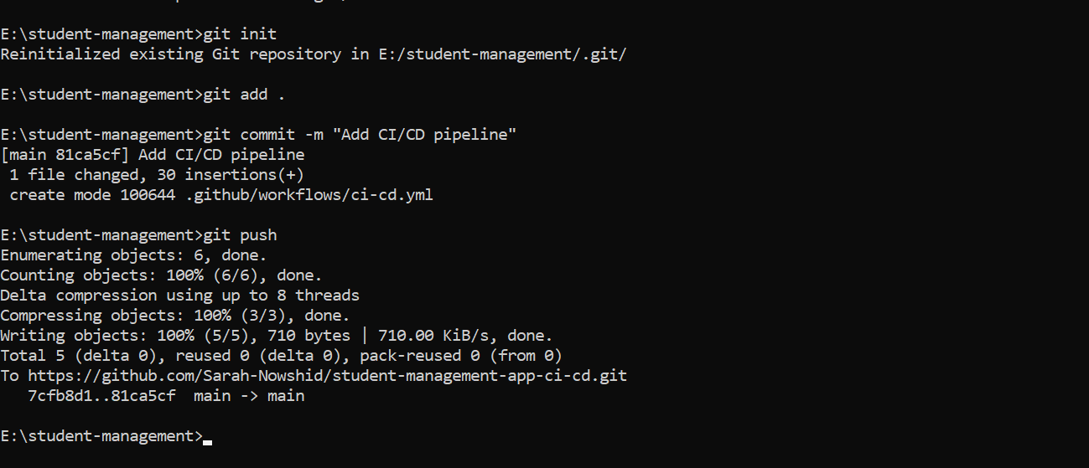

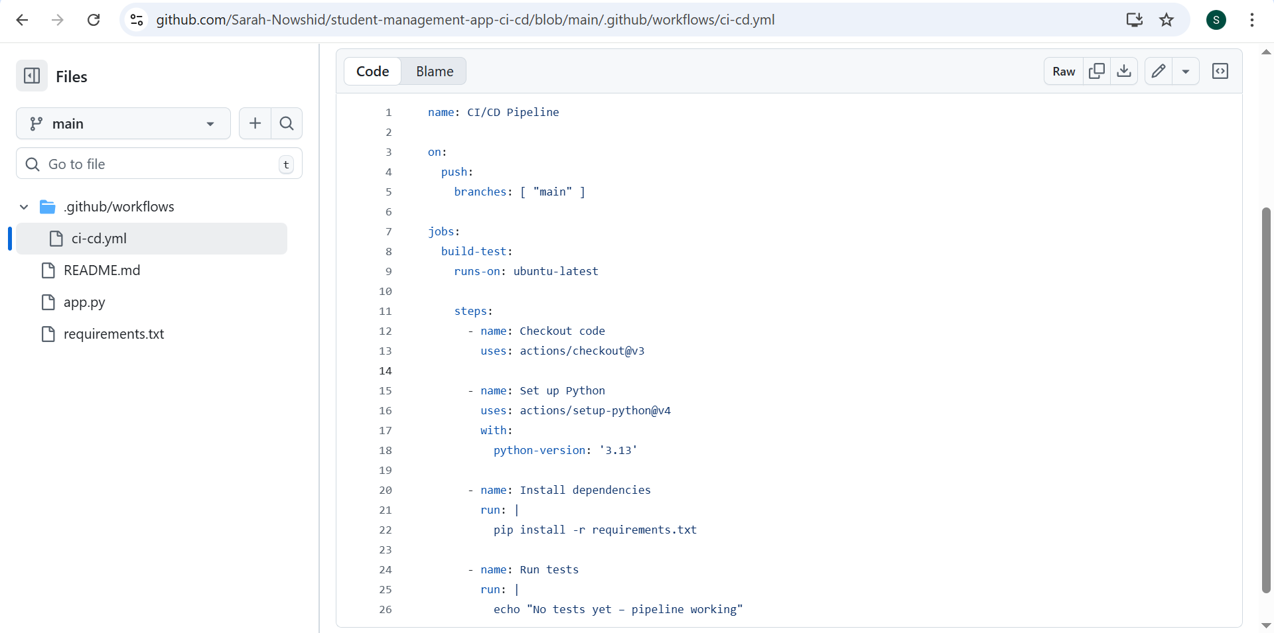

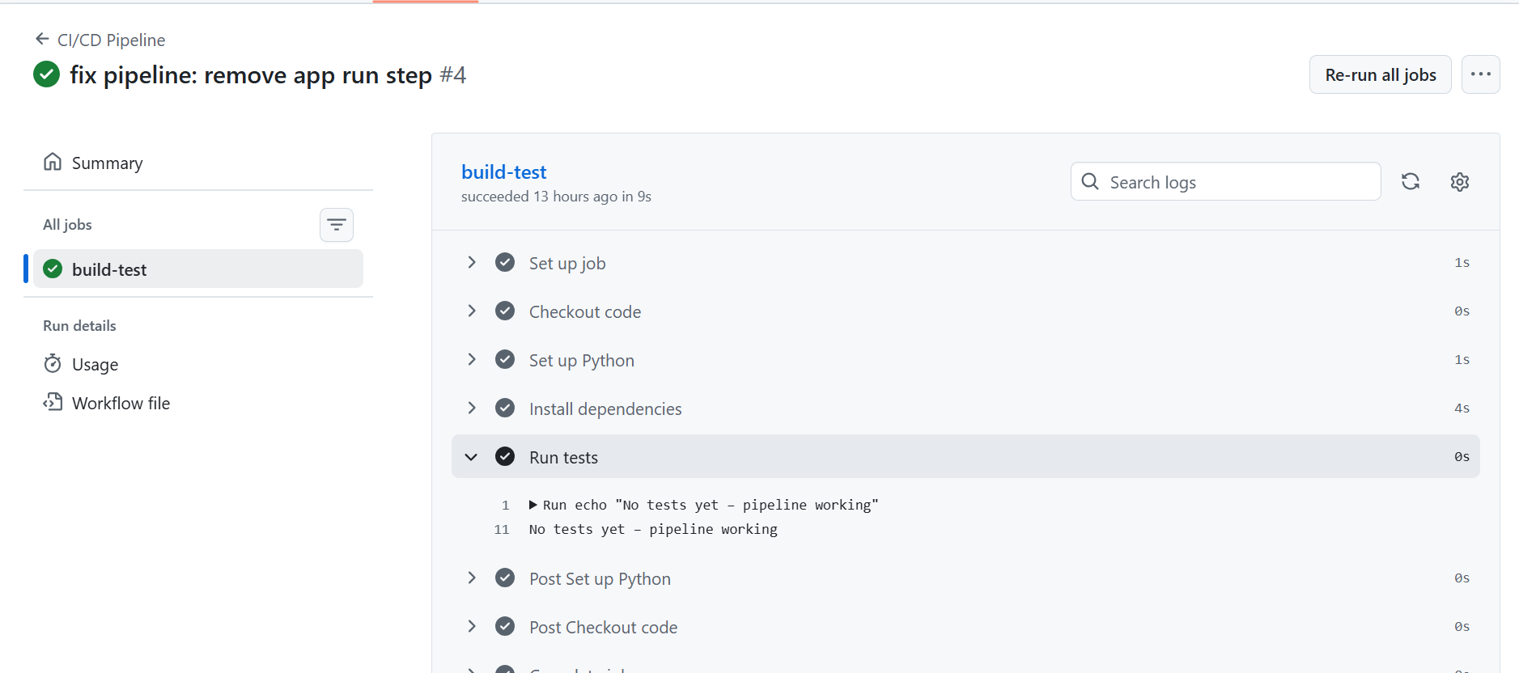
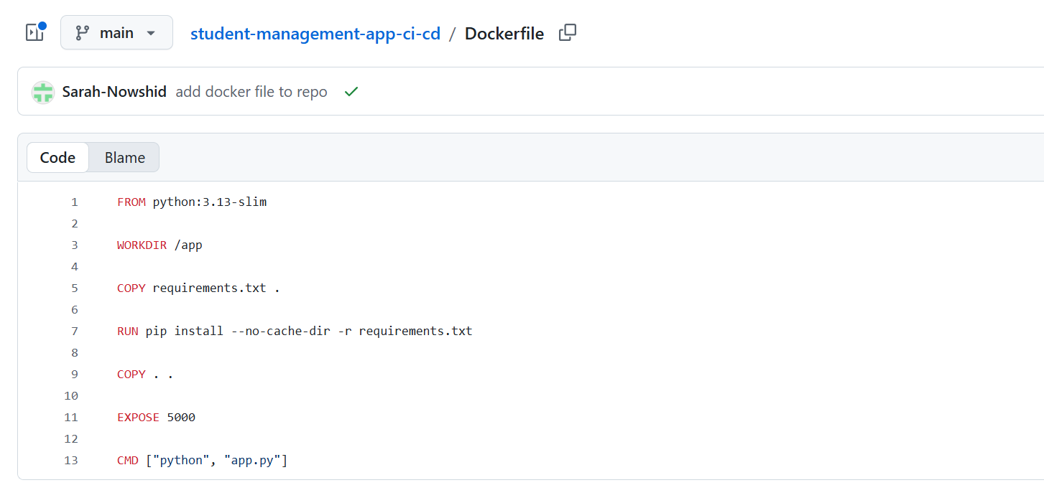
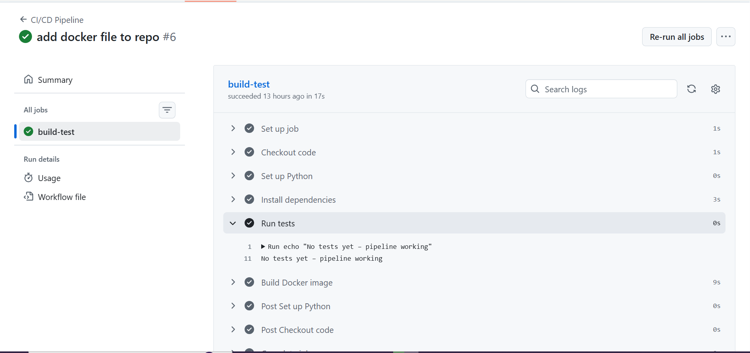

Workflow Explanation
- Code Commit
  - The developer writes or updates code in the Student Management System and pushes it to the GitHub repository.
- CI/CD Trigger
  - GitHub Actions automatically detects the push to the main branch and starts the pipeline.
- Build & Test
  - The pipeline installs all dependencies from requirements.txt.
  - Runs automated tests to ensure the app works correctly.
- Docker Build
  - The application is packaged into a Docker container image using the Dockerfile.
- (Optional) Push to Azure
  - The Docker image can be pushed to Azure Container Registry.
  - Azure Web App or Kubernetes pulls the image and deploys the app automatically.
- Monitoring & Feedback
  - GitHub Actions provides logs and status for each stage.
  - Any failed stage stops the deployment, allowing the developer to fix issues before going live.

Diagram:
GitHub → Actions → Docker → ACR → Azure Web App
a feedback arrow from Azure → GitHub Actions for monitoring/rollback

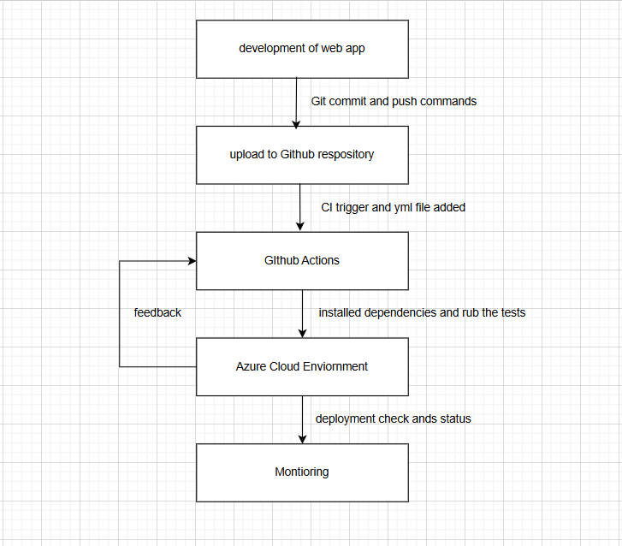

Conclusion:
- Fully automated CI/CD pipeline built using GitHub Actions
- Docker ensures reproducibility and portability
- Pipeline can be extended to Azure deployment for real-world scenarios
- Improves developer productivity, reduces human error, and maintains consistent application builds.

